

Name : Benjamin Danish D
Reg No : 192412544
Course name : Advanced Wireless Communication System
Course code : ECA5610
MATLAB Simulation of Cellular Coverage, Cell Splitting and Handoff in a Multi-Cell Network
Aim:
To model a simplified hexagonal cellular network and study how cell radius affects coverage, estimated user capacity and handoff as a mobile crosses a cell boundary.
Objectives:
- Model adjacent hexagonal cell coverage and identify cell centers and boundaries.
- Estimate the number of cells required to cover a fixed service area for different cell radii.
- Compare estimated users served under an explicit per-cell capacity assumption.
- Simulate a mobile moving across a cell boundary and identify the serving-cell transition.
Requirements:
- Computer with MATLAB R2019b or later.
- No RF hardware is required; this is a geometric and analytical simulation.
Program 1 — Model adjacent hexagonal cell coverage areas
clear;
clc;
close all;

cellRadiusKm = 0.5;

% Axial coordinates for the central cell and its six neighbours
axial = [ ...
0, 0;
1, 0;
1, -1;
0, -1;
-1, 0;
-1, 1;
0, 1];

% Convert axial coordinates to Cartesian cell-centre positions
xCenter = sqrt(3) * cellRadiusKm .* ...
(axial(:,1) + axial(:,2)/2);
yCenter = 1.5 * cellRadiusKm .* axial(:,2);

% Hexagon vertices
angle = deg2rad(30:60:330);

figure;
hold on;
for k = 1:length(xCenter)
xVertex = xCenter(k) + cellRadiusKm * cos(angle);
yVertex = yCenter(k) + cellRadiusKm * sin(angle);
patch(xVertex, yVertex, [0.80 0.90 1.00], ...
'EdgeColor', [0.10 0.25 0.50], ...
'LineWidth', 1.5);

text(xCenter(k), yCenter(k), sprintf('Cell %d', k), ...
'HorizontalAlignment', 'center', ...
'FontWeight', 'bold');
end

axis equal;
grid on;
xlabel('Horizontal distance (km)');
ylabel('Vertical distance (km)');
title(sprintf('Adjacent Hexagonal Cells (Radius = %.2f km)', ...
cellRadiusKm));
hold off;
Output (Seven adjacent hexagonal cells):
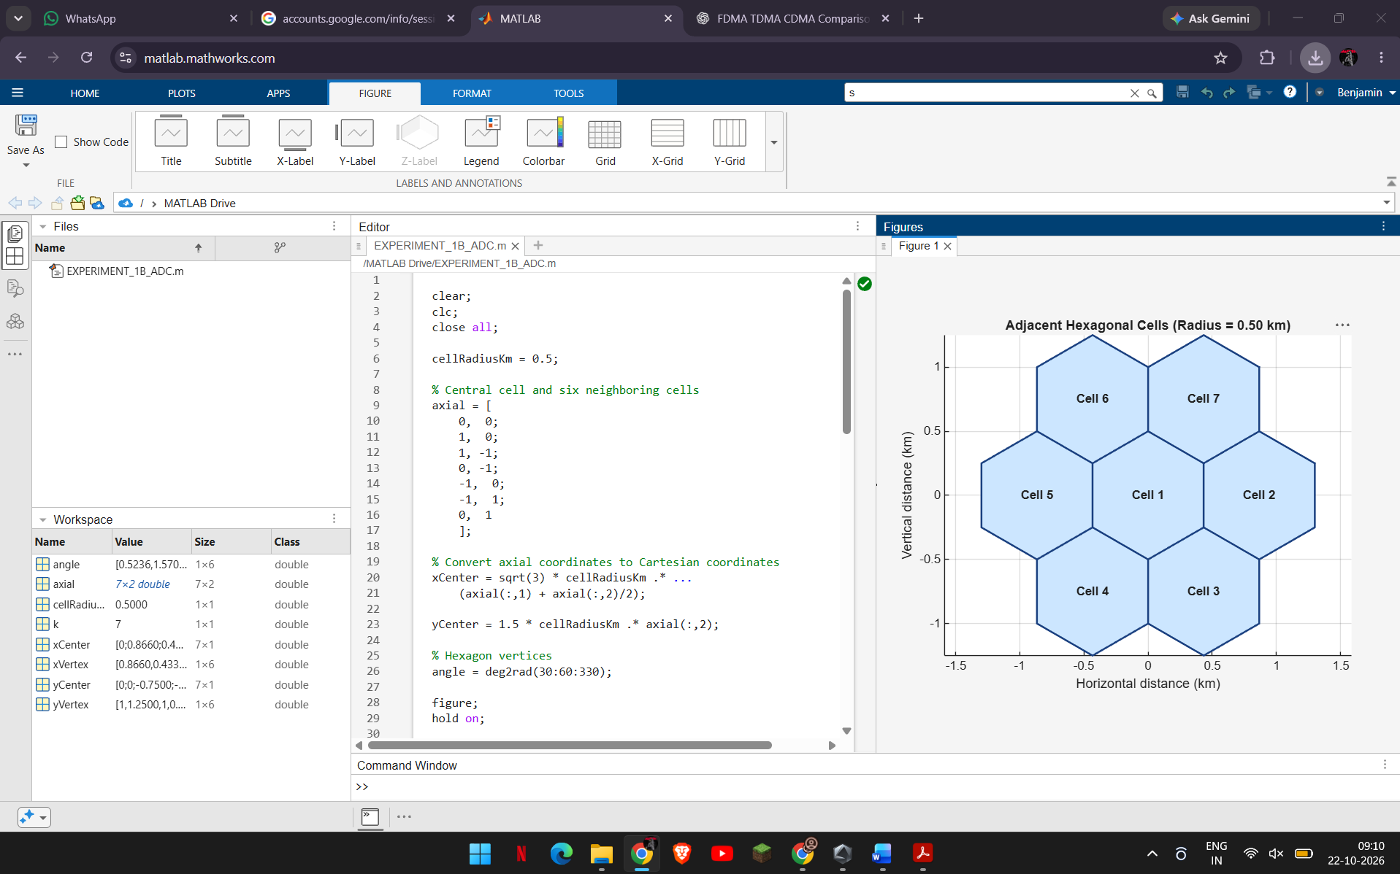
Program 2 — Estimate cell count for different cell radii
clear;
clc;
close all;

studyAreaKm2 = 4.0;
cellRadiiKm = [1.00, 0.75, 0.50];

% Area of a regular hexagonal cell
cellAreaKm2 = (3 * sqrt(3) / 2) .* cellRadiiKm.^2;

% Approximate cell count, rounded up to cover the study area
estimatedCells = ceil(studyAreaKm2 ./ cellAreaKm2);

results = table(cellRadiiKm', cellAreaKm2', estimatedCells', ...
'VariableNames', {'CellRadius_km', 'CellArea_km2', ...
'EstimatedNumberOfCells'});

disp('Estimated cells required:');
disp(results);

figure;
bar(cellRadiiKm, estimatedCells, 0.6);
xlabel('Cell radius (km)');
ylabel('Estimated number of cells');
title('Cell Radius versus Estimated Number of Cells');
grid on;
Output (Table and bar chart):
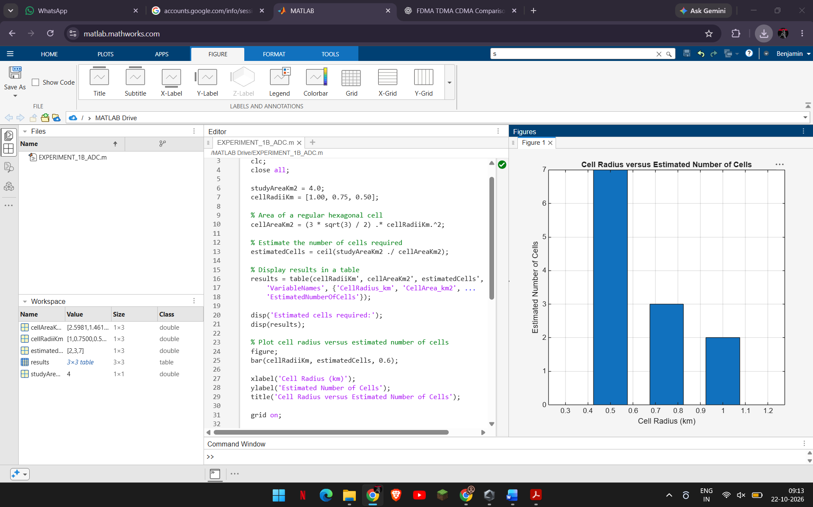
Program 3 — Compare user capacity for different cell sizes
clear;
clc;
close all;

studyAreaKm2 = 4.0;
userDensityPerKm2 = 30;
maxUsersPerCell = 50;
cellRadiiKm = [1.00, 0.75, 0.50];

totalDemand = studyAreaKm2 * userDensityPerKm2;

% Hexagonal cell area and approximate cell count
cellAreaKm2 = (3 * sqrt(3) / 2) .* cellRadiiKm.^2;
estimatedCells = ceil(studyAreaKm2 ./ cellAreaKm2);

% Estimate network capacity and users served
networkCapacity = estimatedCells .* maxUsersPerCell;
usersServed = min(totalDemand, networkCapacity);

results = table(cellRadiiKm', estimatedCells', networkCapacity', ...
usersServed', ...
'VariableNames', {'CellRadius_km', 'EstimatedNumberOfCells', ...
'EstimatedNetworkCapacity', 'EstimatedUsersServed'});

disp('Estimated user capacity:');
disp(results);

figure;
bar(cellRadiiKm, [networkCapacity' usersServed'], 'grouped');
hold on;
yline(totalDemand, '--r', 'Total user demand');
xlabel('Cell radius (km)');
ylabel('Number of users');
title('Cell Size and Estimated User Capacity');
legend('Network capacity', 'Users served', 'Total demand', ...
'Location', 'northwest');
grid on;
hold off;
Output (Table and grouped bar chart):
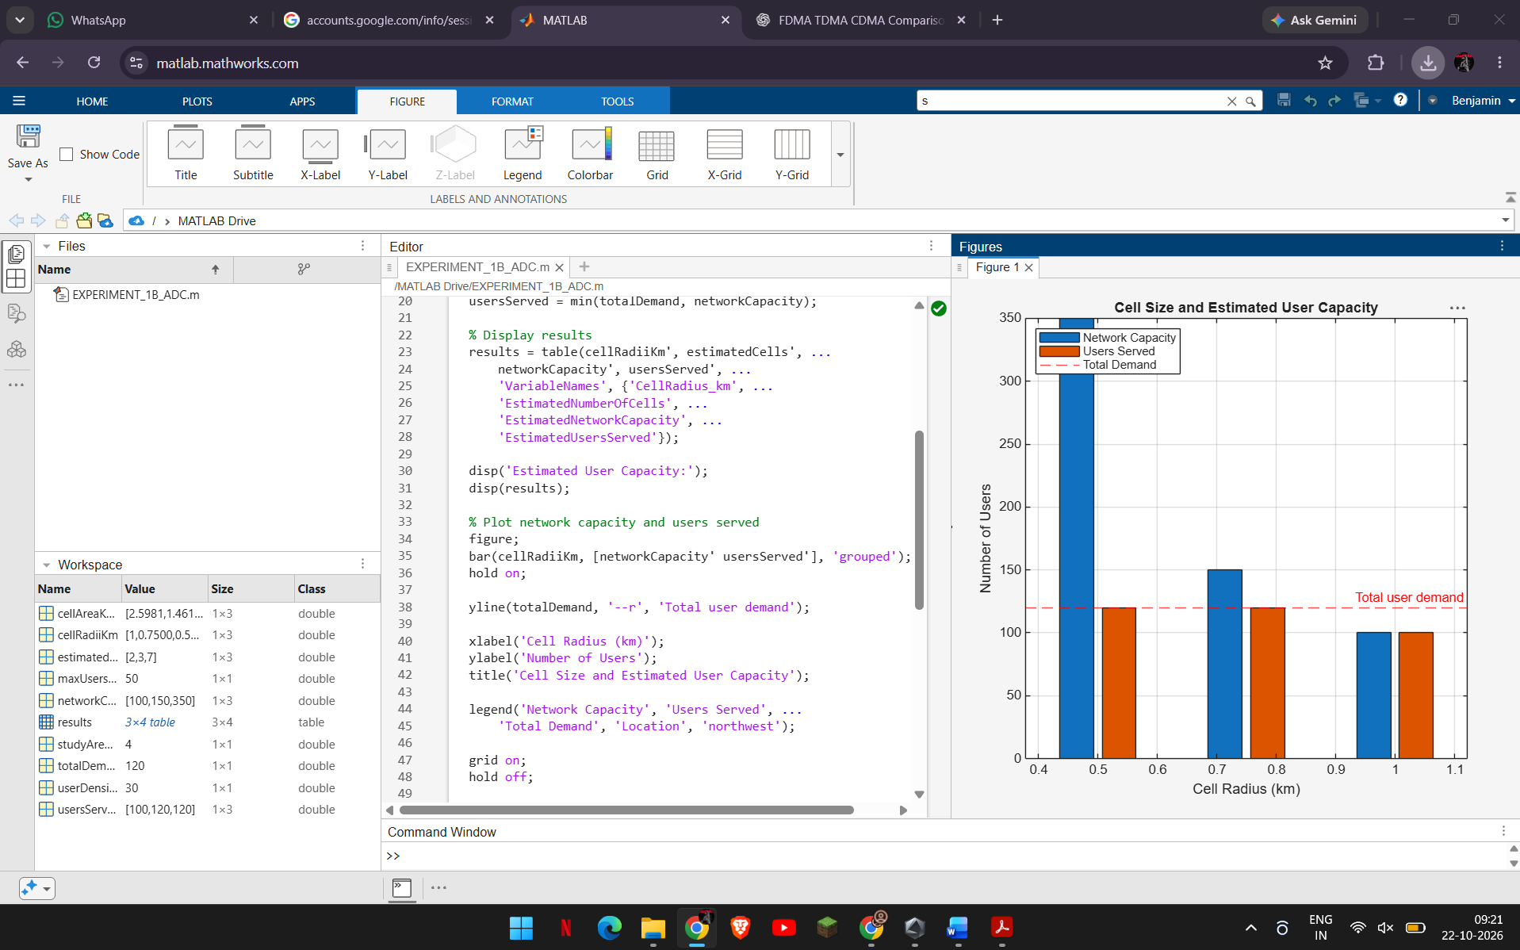
Program 4 — Simulate movement and identify the handoff point
clear;
clc;
close all;

cellRadiusKm = 0.5;
radiusM = cellRadiusKm * 1000;

% Centre-to-centre spacing of horizontally adjacent hexagonal cells
separationM = sqrt(3) * radiusM;

% Mobile user moves from base station 1 toward base station 2
xMeters = linspace(0, separationM, 201);

% Distance from the mobile to each base station
minimumDistanceM = 20; % Prevent log10(0) at a base-station location
distance1M = max(abs(xMeters), minimumDistanceM);
distance2M = max(abs(xMeters - separationM), minimumDistanceM);

% Illustrative log-distance path-loss parameters
transmitPowerdBm = 30;
pathLossAt1m_dB = 40;
pathLossExponent = 3.5;

% Estimate received power from each base station
receivedPower1dBm = transmitPowerdBm - pathLossAt1m_dB ...
- 10 * pathLossExponent .* log10(distance1M);

receivedPower2dBm = transmitPowerdBm - pathLossAt1m_dB ...
- 10 * pathLossExponent .* log10(distance2M);

% Handoff occurs when base station 2 becomes stronger
handoffIndex = find(receivedPower2dBm >= receivedPower1dBm, 1, 'first');
handoffPositionM = xMeters(handoffIndex);

fprintf('Estimated handoff position: %.1f m from base station 1\n', ...
handoffPositionM);

figure;
plot(xMeters / 1000, receivedPower1dBm, ...
'b', 'LineWidth', 1.5);
hold on;
plot(xMeters / 1000, receivedPower2dBm, ...
'r', 'LineWidth', 1.5);
xline(handoffPositionM / 1000, '--k', 'Estimated handoff');

xlabel('Mobile-user position (km)');
ylabel('Estimated received power (dBm)');
title('Received Signal Strength Between Adjacent Cells');
legend('Base station 1', 'Base station 2', ...
'Location', 'best');
grid on;
hold off;
Output (Received-power plot and handoff position):
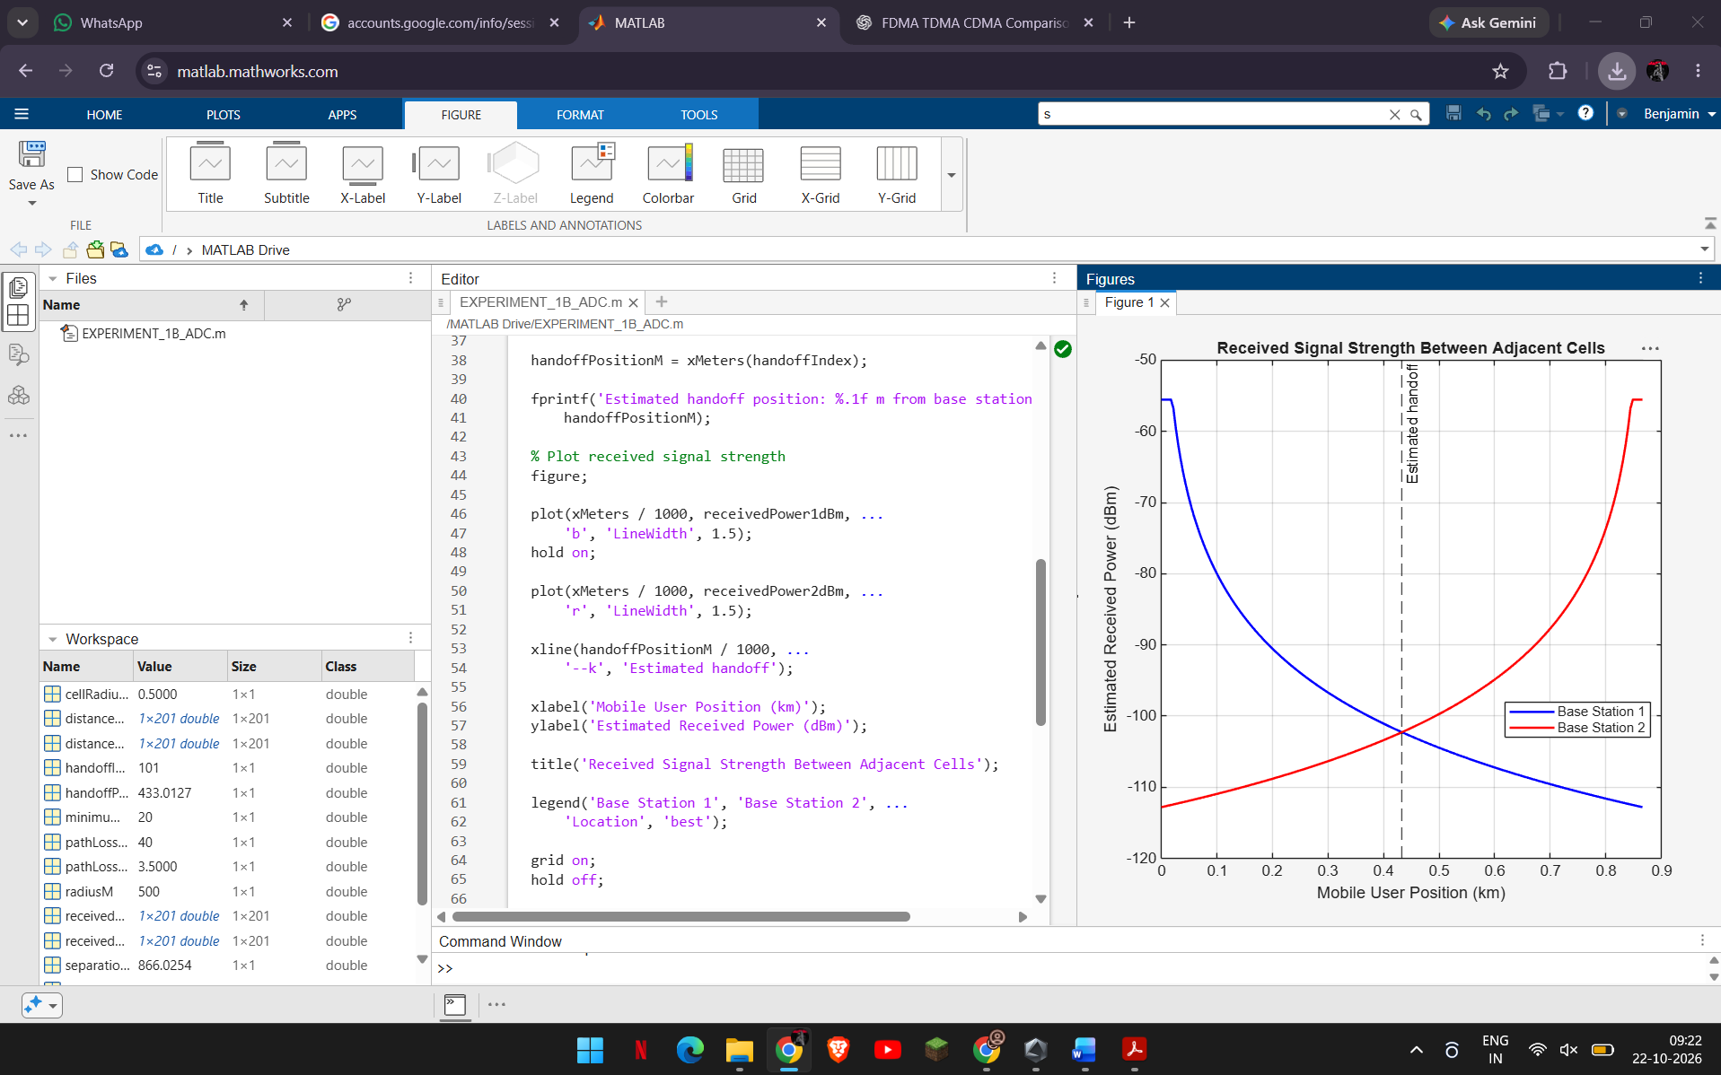
Analysis Questions:
- Why does halving the radius increase the idealized number of cells by approximately four for a fixed area?
- What assumption makes the estimated total user capacity scale directly with the number of cells?
- At what position does the nearest-center rule switch the serving cell, and why is that point the geometric boundary?
- Name two radio or network factors absent from this model that could shift or delay a real handoff.
Conclusion:
Cell radius strongly changes the idealized cell count: for a fixed service area, the number of cells grows roughly with the inverse square of the radius, so the assumed network capacity grows with it. The simulated handoff occurs at about 433 m from base station 1, close to the midpoint between the two base stations. The model uses ideal hexagons, an area-ratio count, fixed per-cell capacity and nearest-center handoff; it does not model RF propagation, overlap, fading, load or handoff timers.

